Clone the Repo

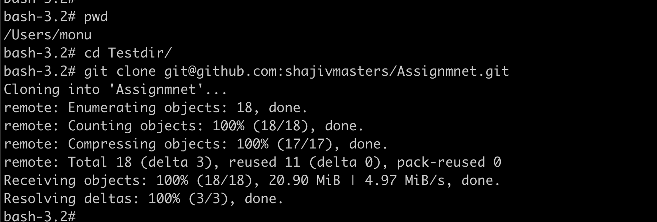

 Initialize terraform to download t haws provided

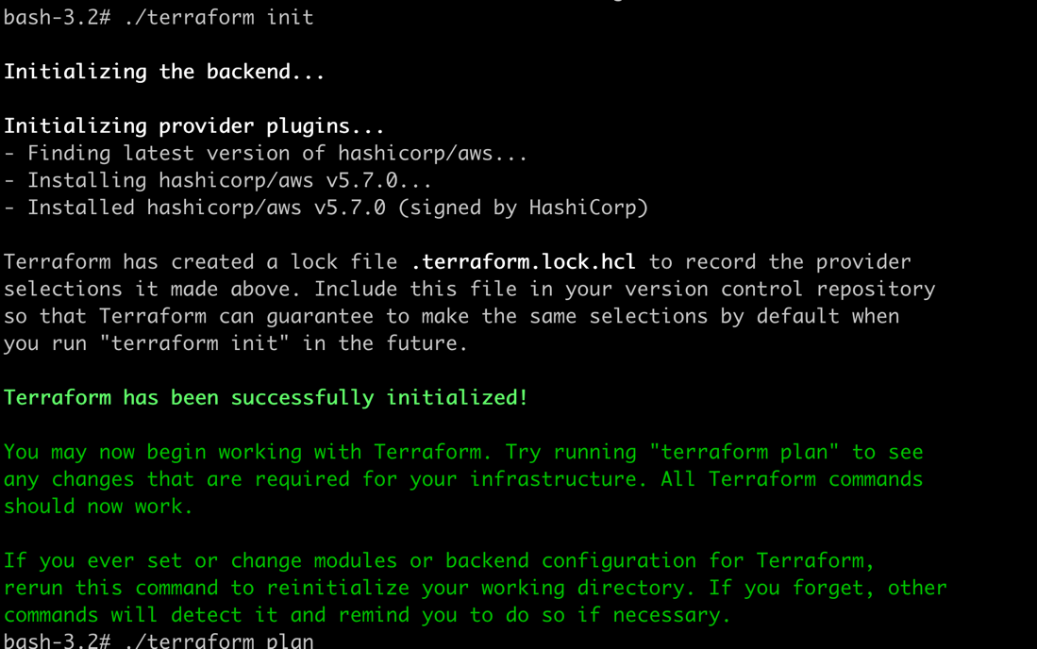

Terraform plan to prepare for the deployment

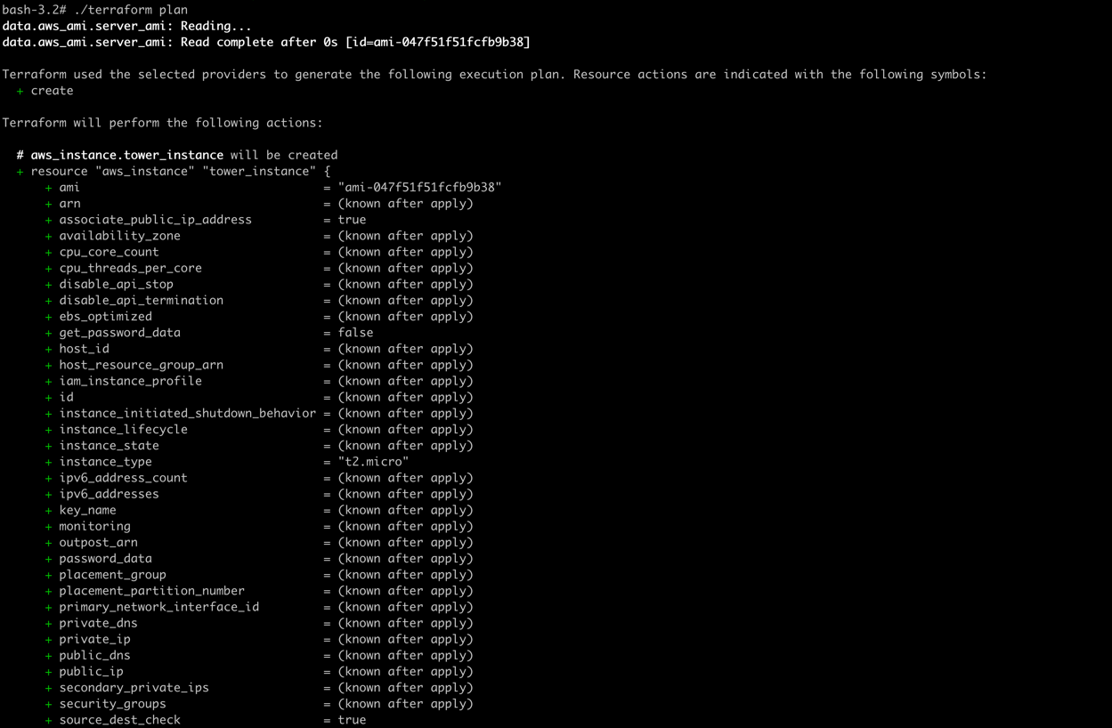

.

.

.

.

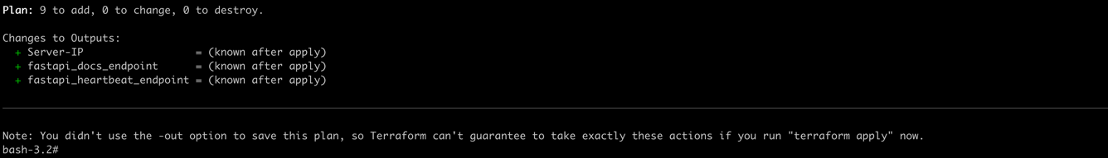

Terraform apply to deploy the Infrastructure as a Code

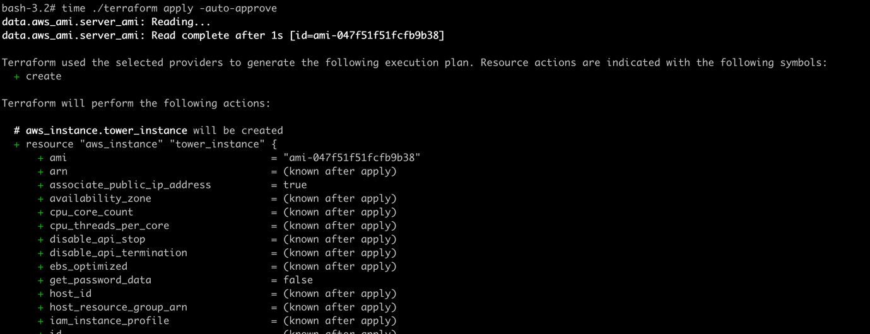

.

.

.

.

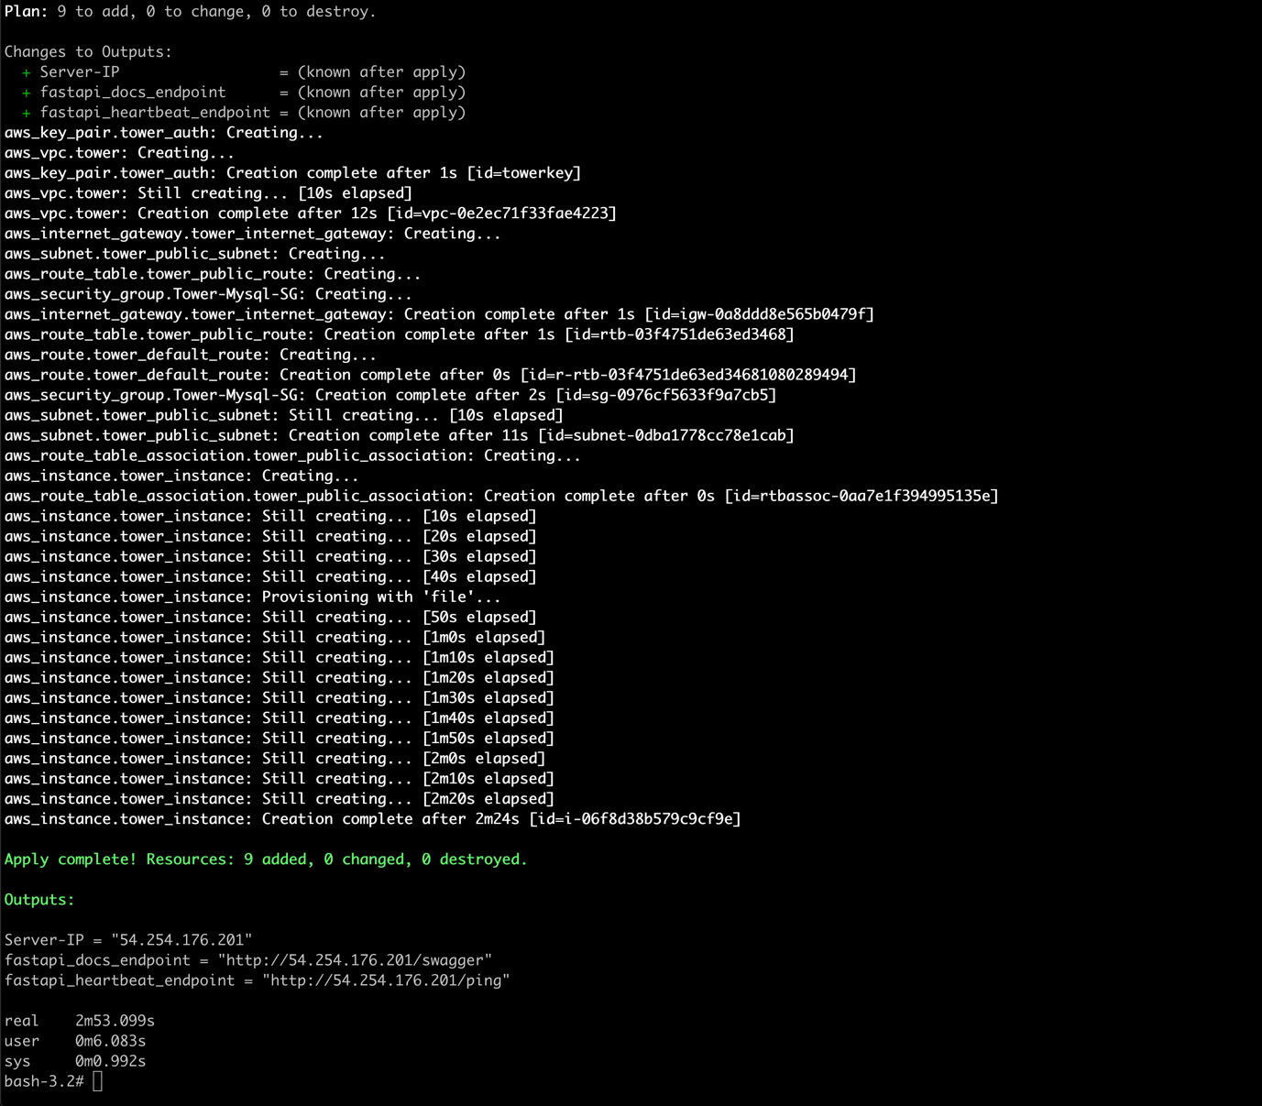

Check the Terrform states

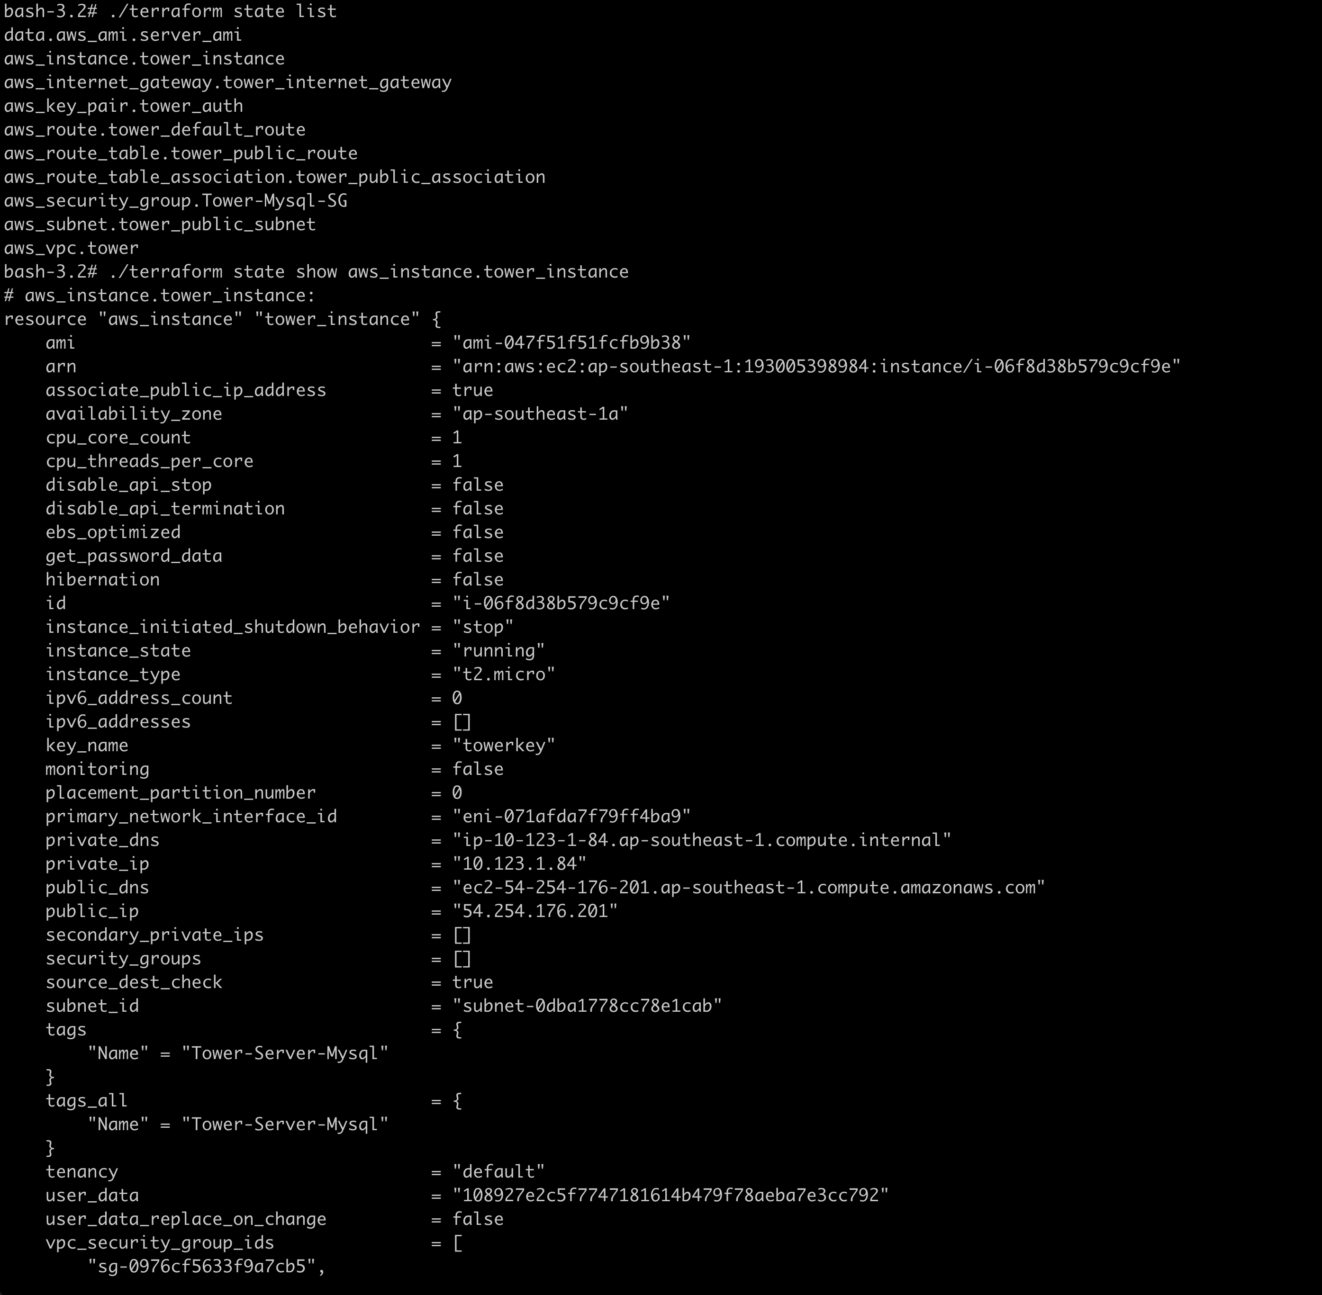

You can see in the Instance page on the AWS console

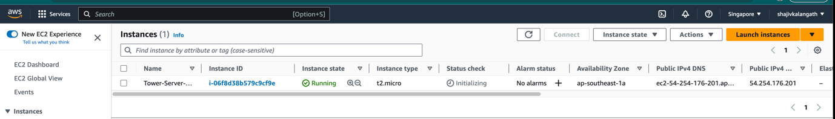

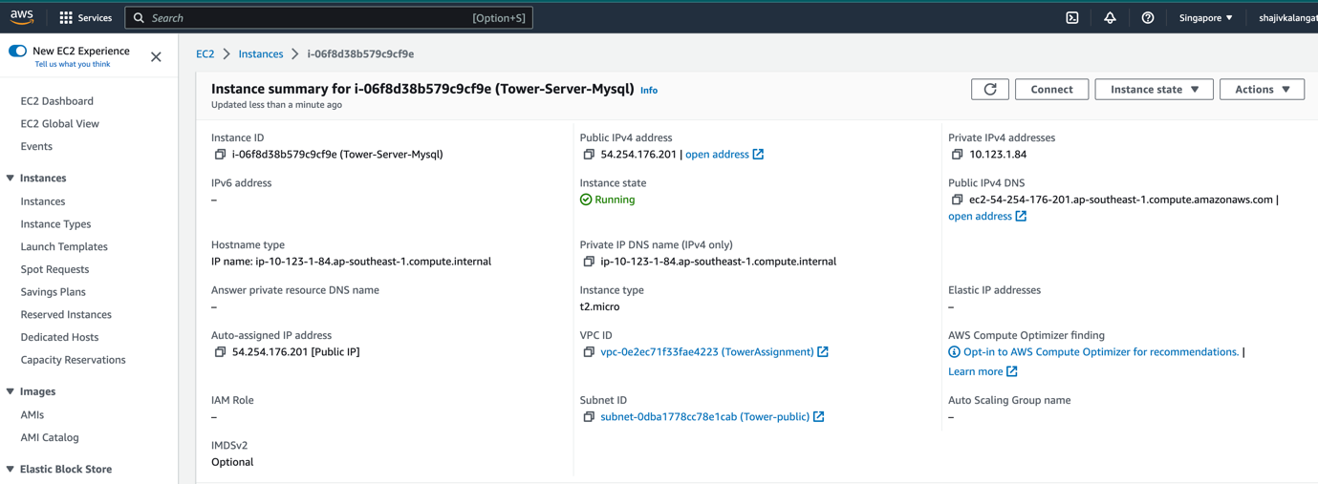

Try connecting after 3- 5 minutes. You can see that it is completed. Deployment logs wil be in /var/log/aws_install.log

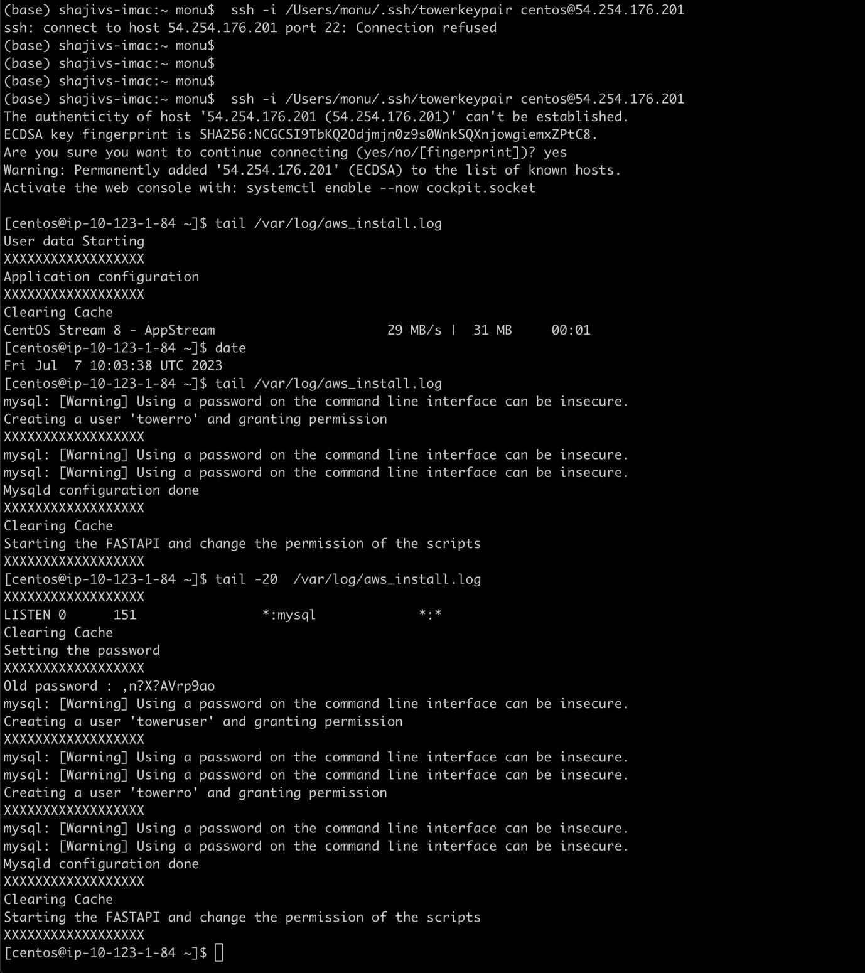

You can see that by default it listen to all the interfaces “*”

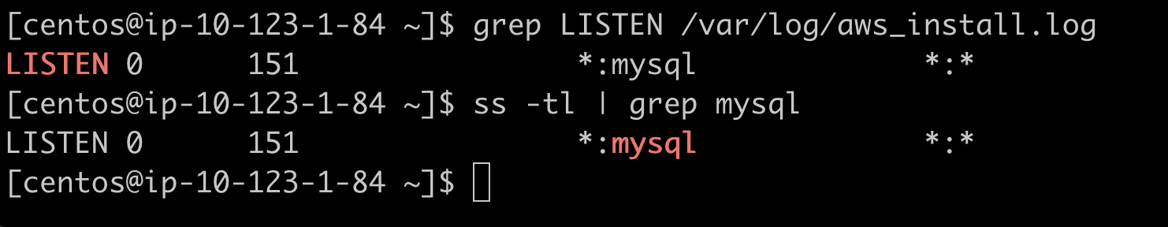

FastAPI application is also up and running . You can see the swagger page to test and also you can try ping pong

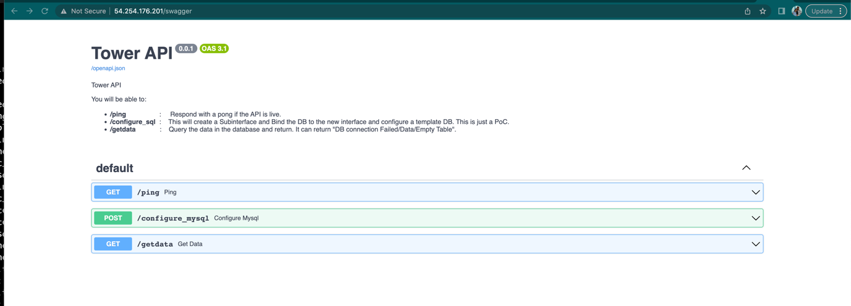

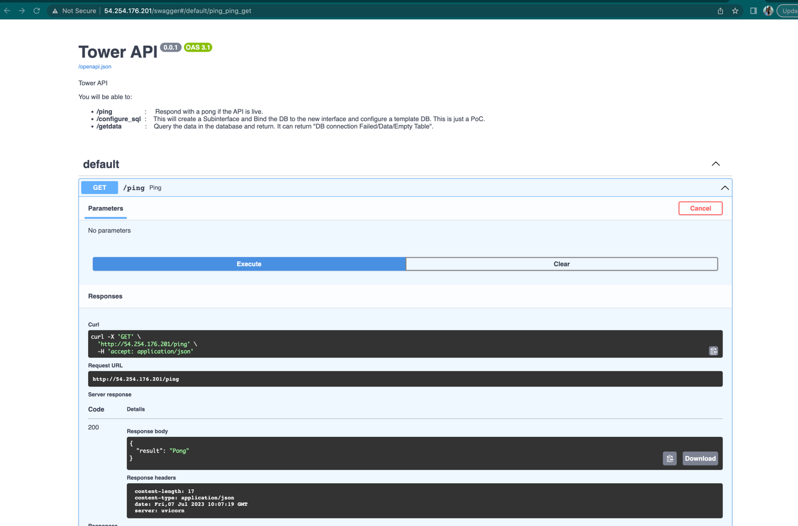

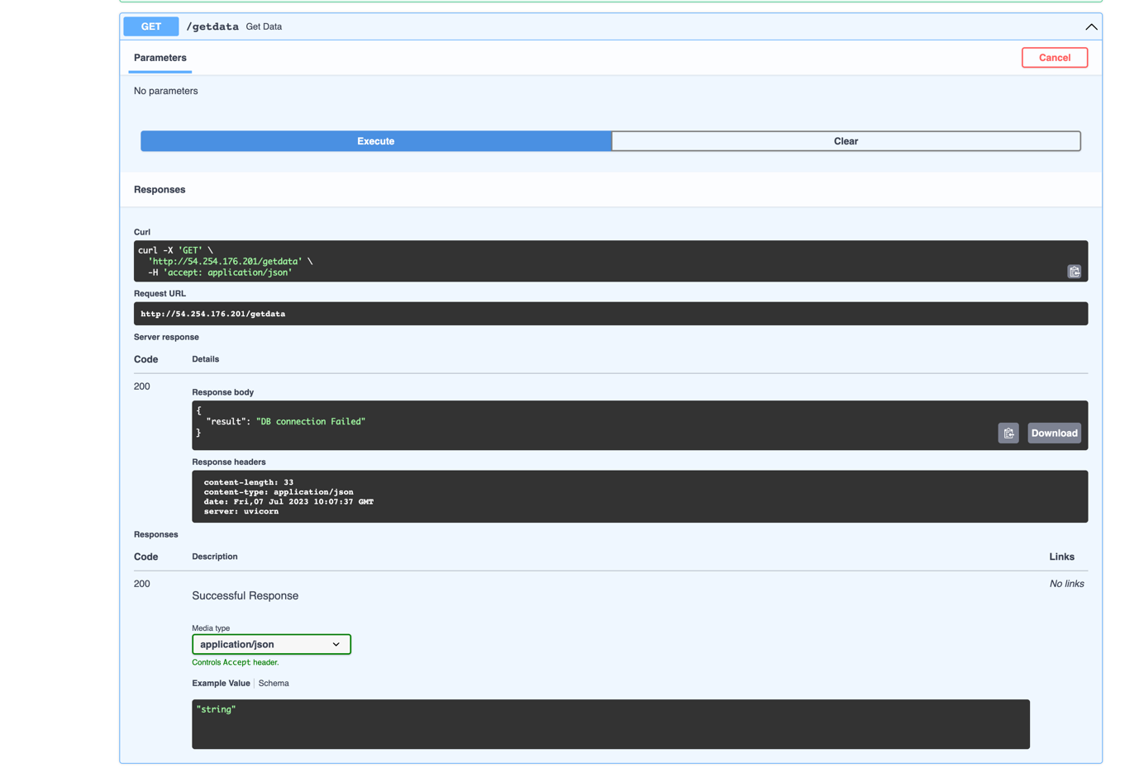

You can test this from the deployment server as well .

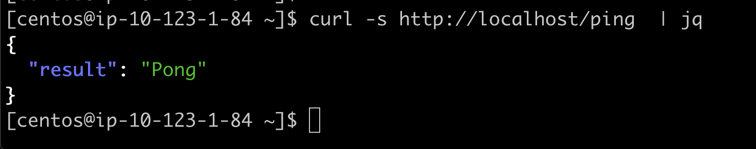

You can see that there is no subinterface now and also no reference in the my.cf ( mysql configuration page) . Running the /home/centos/scripts/dbmanage.py create will boot strap the DB

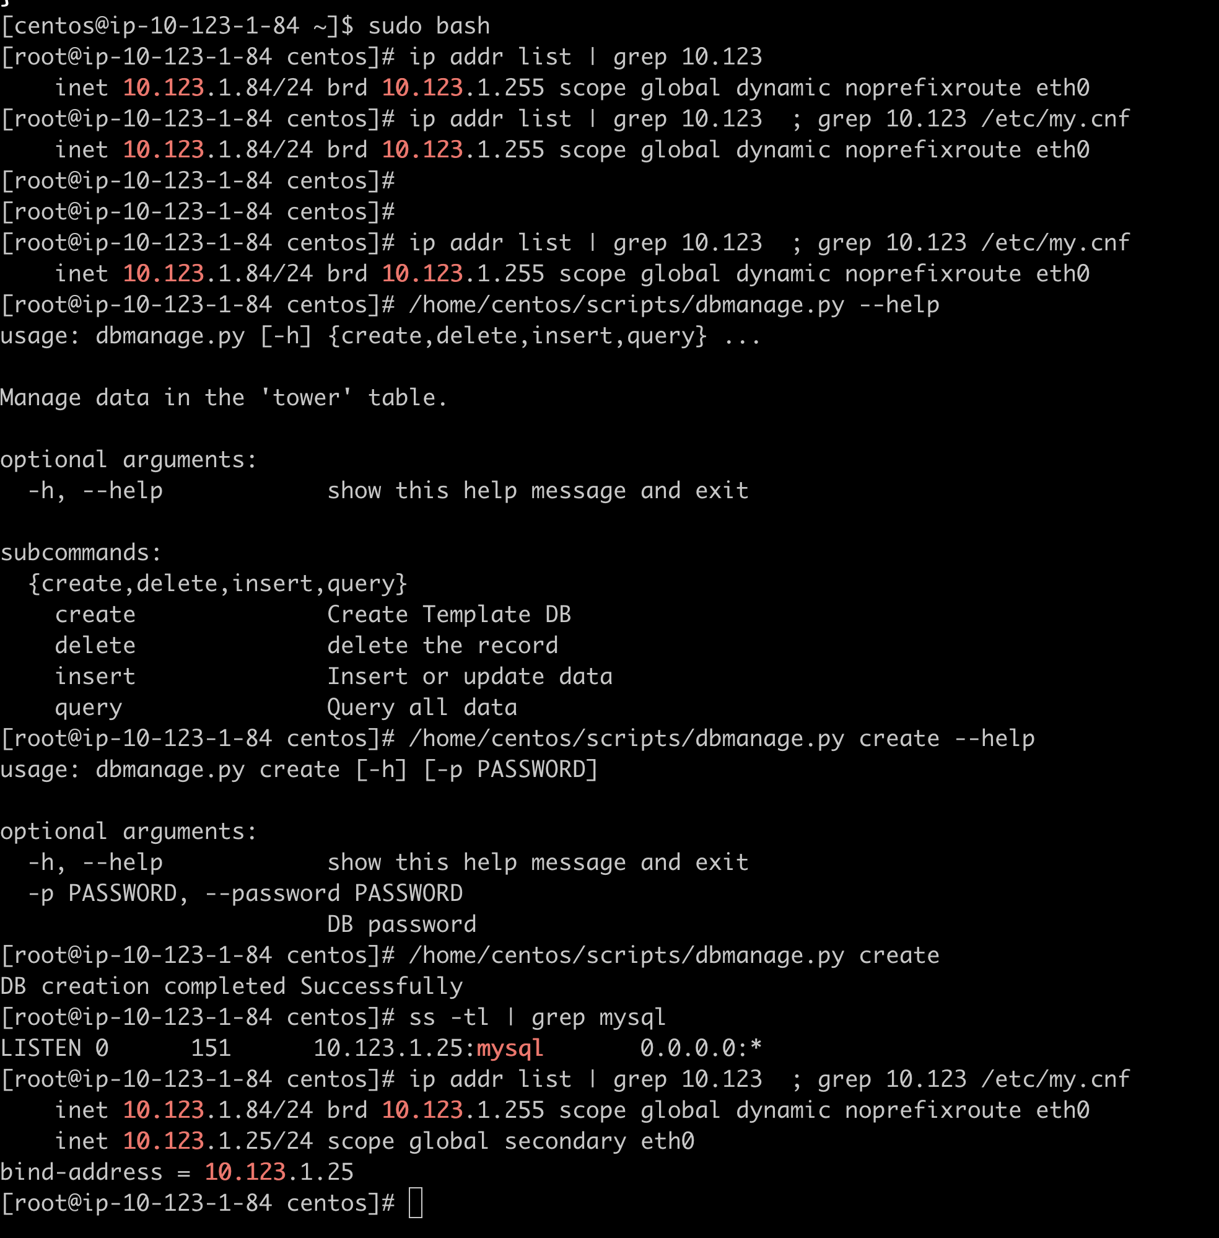

Part of the infrastructure deployment there are 2 account create “towerro” and “toweruser”. We are able to connect to it .

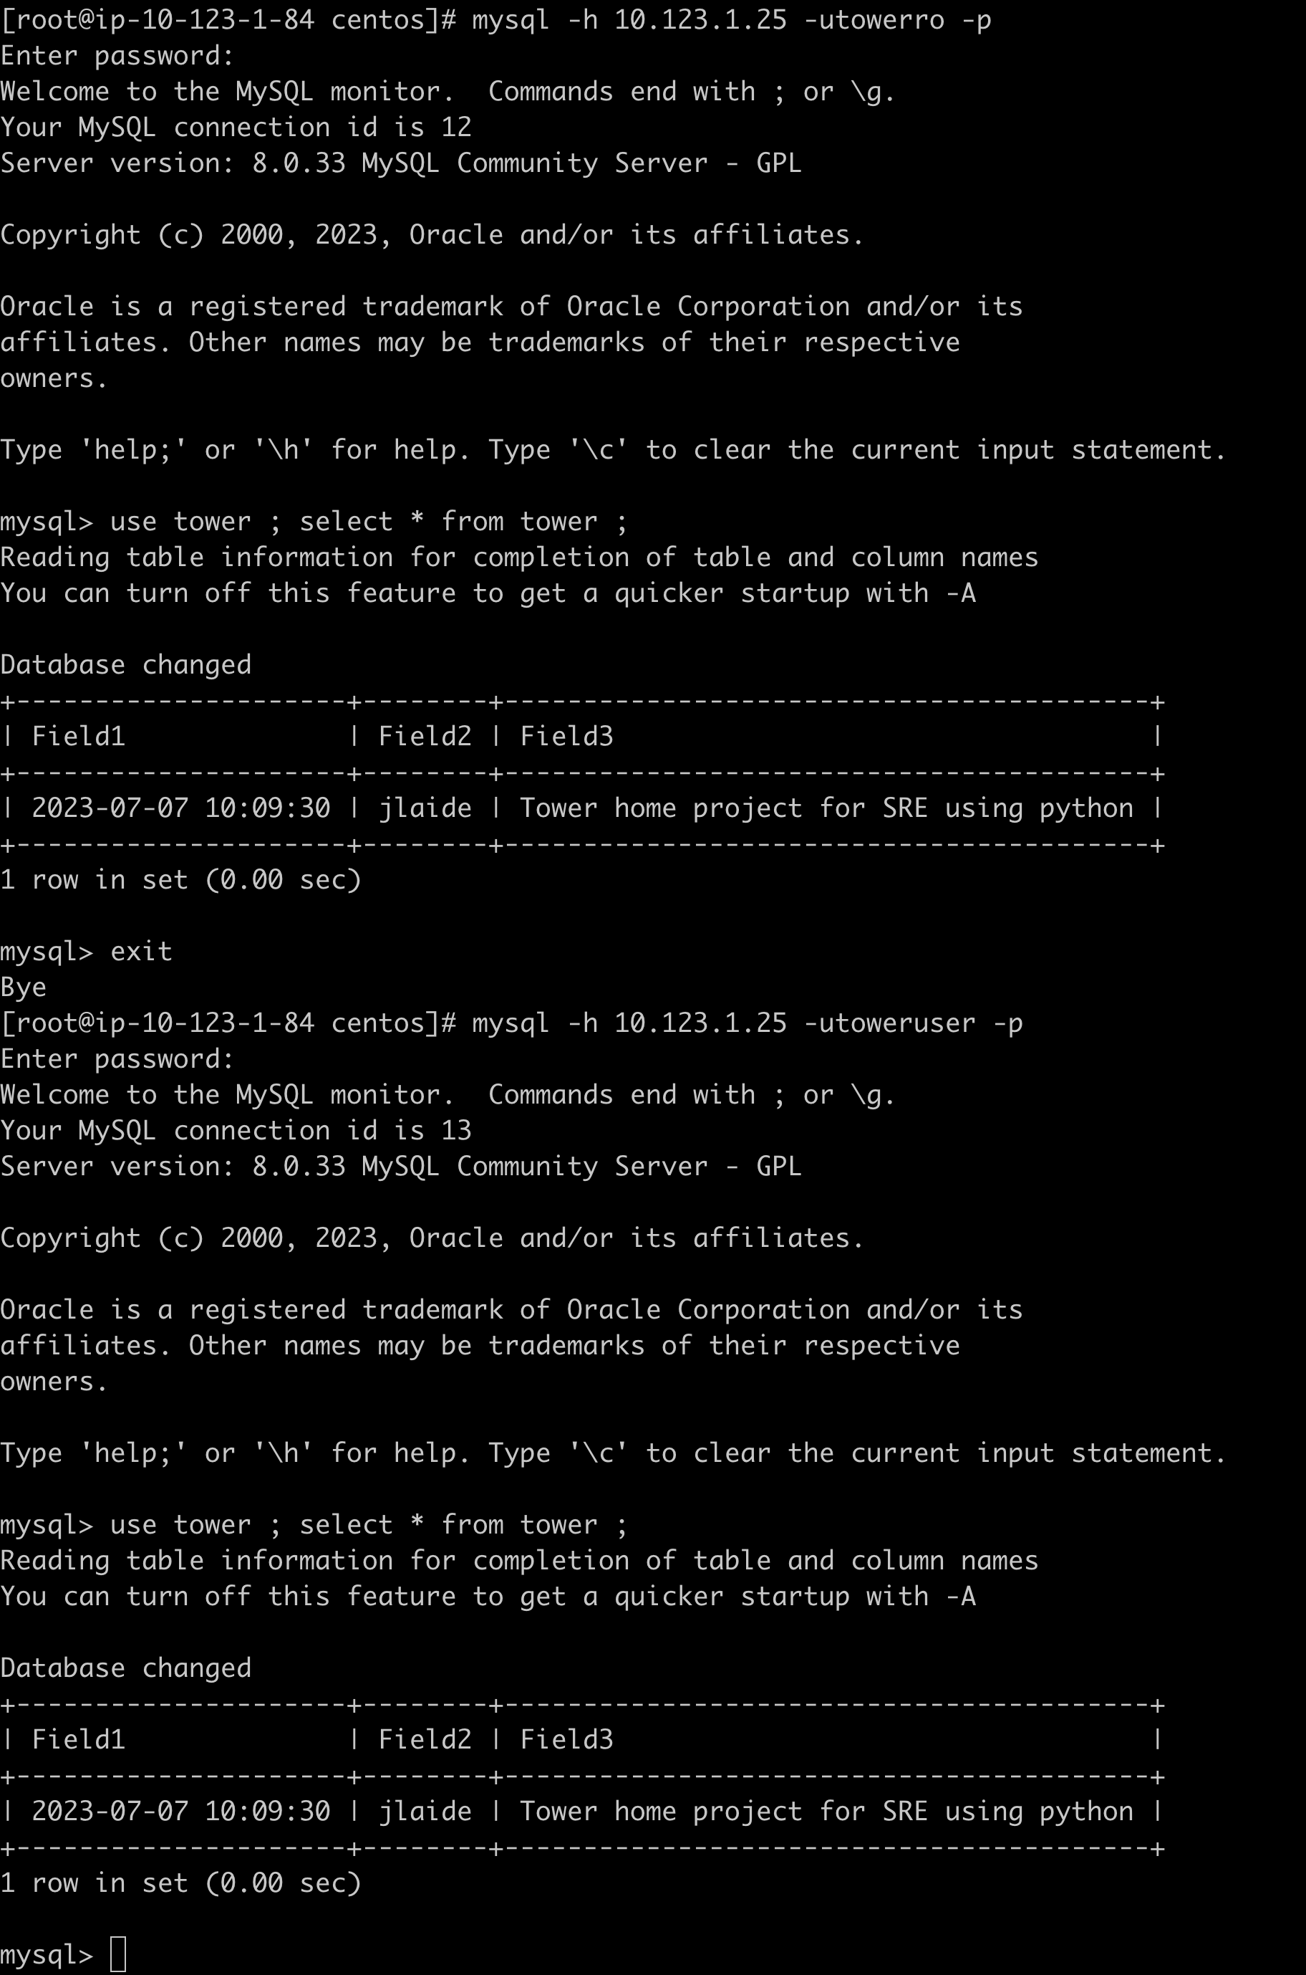

Below are some of the example to Query /Insert /Update and Delete the Record

